Logging in to the Employee Portal
- Go to https://ess.hingham-ma.gov/mss
- Click “Log In” in the top-right corner.
- Your username is HPS+your first initial+your middle initial+your 4 digit employee code.
  - For example, my username is HPSJM****
  - To find your employee code, you have to look at one of your paystubs.
  - To look at one of your paystubs, click on the direct deposit emails
  - Scroll down and click “Download” and then click “Open.”
  - Enter the last four digits of your social security number as your password.
- Initially your password is the last four digits of your social security number. You will immediately be required to change your password.
  - It FORCES you to choose a password that has a letter, number, and unique character like the * or the % key.
  - I suggest writing it down…these are not easy passwords to remember.

**If at some point you can’t remember your password, please email Elaine Smoot at esmoot@hinghamschools.org to have it reset.

Checking Your PayStub Information
You can log on to the Employee Self Service portal and get info there.

Go to https://ess.hingham-ma.gov/mss
Your username is HPSxx1111The first time you visit, your password is last four numbers of your social security number, which you’ll be asked to change to a different password right away.

Once you log in, tap “Employee Self Service on the left side and you’ll get a screen like this:

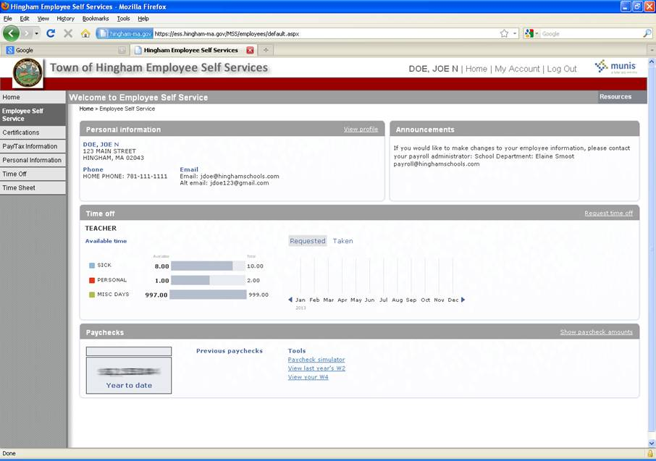

In the “Paychecks” section, the numbers are fuzzy on purpose. When you have privacy and are ready to look at your pay, simply click “Show paycheck amounts” here and the numbers will un-fuzz.

Requesting a Day Off
Log in

Tap “Employee Self Service” on the left side and, from the drop down box, choose “Time Off” then “Request Time Off” below that.

The program will walk you through 4 quick steps to request time off:

1. Tap on the calendar to select date(s) you will be absent.
Click “Continue”.
2. Choose Type of absence (eg, sick, personal)
Click “Continue”.
3. Change from full day to .5 if you are only using a half day
Click “Continue”.
4. Choose reason from the drop down box – ignore the word “optional” in the box. It is NOT optional, please choose reason and, if necessary, provide additional information in the Comments box.
Click “Make Request” and you are done.

Your request will be forwarded to your supervisor for approval.

Canceling a Time Off Request
Sign in as usual, go to “Time Off” and “My Requests”, then click “Cancel” beside the original request:
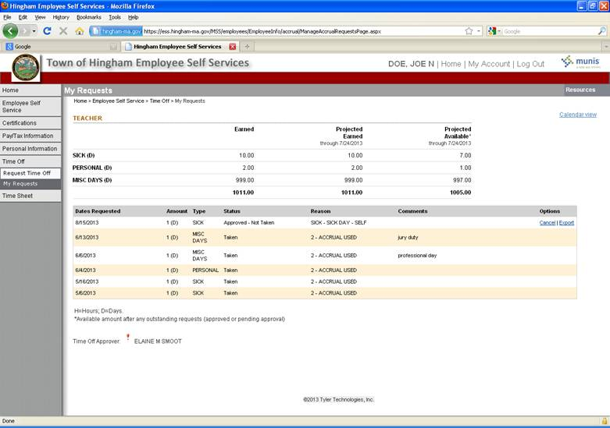

Changing Your Address
Tap “Employee Self Service” on the left and, from the drop down box, choose “Personal Information”.

Click “change” beside the Address header and you’re on your way.

Employee Resources (Staff Documents)

Once you have logged in, tap “Employee Self Service” on the left hand side to open your page, then look for “Resources” in the upper right corner where you’ll find all our forms including xxxxxxx.

Paycheck Simulator (What your Paycheck would look like if you change your exemptions)

Look for the “Paycheck simulator” button under the word “Tools” in the Paychecks section. You can change the number of exemptions or the amount of certain pre-tax deductions then hit “Calculate” to see what the difference will be.

If you decide to change anything, forms are also here; look for “Resources” in the upper right side of your page.

Please let me know if you have any questions.

